|  |  |
| --- | --- |
| cetlogo ***CHEMICAL ENGINEERING TRANSACTIONS***  ***VOL. 92, 2022*** | A publication of  aidiclogo_grande |
| The Italian Association  of Chemical Engineering  Online at www.cetjournal.it |
| Guest Editors: Rubens Maciel Filho, Eliseo Ranzi, Leonardo Tognotti  Copyright © 2022, AIDIC Servizi S.r.l. **ISBN** 978-88-95608-90-7; **ISSN** 2283-9216 | |

Hydrothermal Liquefaction Process to Obtain Sludge-Derived Bio-Fuels: Setup of the Experimental Apparatus and Preliminary Tests

Francesca Di Lauroa, Marco Balsamoa, Roberto Solimeneb,\*, Piero Salatinoc, Fabio Montagnaroa.

aDipartimento di Scienze Chimiche, Università degli Studi di Napoli Federico II, Complesso Universitario di Monte Sant’Angelo, 80126 Napoli, Italy

bIstituto di Scienze e Tecnologie per l’Energia e la Mobilità Sostenibili, Consiglio Nazionale delle Ricerche, Piazzale V. Tecchio 80, 80125 Napoli, Italy

cDipartimento di Ingegneria Chimica, dei Materiali e della Produzione Industriale, Università degli Studi di Napoli Federico II, Piazzale V. Tecchio 80, 80125 Napoli, Italy

[roberto.solimene@stems.cnr.it](mailto:roberto.solimene@stems.cnr.it)

The increasing interest in renewable energies sources, alternative to traditional fossil fuels, is justified by both the growing energy demand and the necessity to reduce greenhouse gases emissions related to the power sector. In this context, the production of bio-oil (or bio-crude) as liquid fuel through the innovative hydrothermal liquefaction (HTL) process is of particular interest, especially when applied to biomass with high water content. In fact, water is in sub-critical state under typical HTL conditions and acts as solvent, catalyst, and reaction medium. Therefore, HTL allows to exploit the water content of biomass, thus avoiding the high energy demand of the dewatering step associated with other thermo-chemical processes (e.g., gasification, pyrolysis, etc.). For the HTL process performed in batch reactors, the minimisation of thermal transients is crucial to both obtain a high-yield bio-crude with more attractive energy properties and limit the formation of undesirable products. In this work, the setup of a lab-scale HTL apparatus was performed so to limit thermal transients, and some preliminary tests were carried out on a municipal sludge in order to evaluate the yield of the obtained bio-crude.

* 1. Introduction

According to International Energy Agency (IEA), in 2019, the world total energy supply reached 7.2×108 TJ and energy generation from fossil fuels accounted for 80.9% of the total world gross energy production compared to 19.1% represented by renewable sources (biofuels and nuclear, wind, solar, etc.). The use of biomass (e.g., lignocellulosic substrates, sludges, micro and macroalgae) in renewable fuels production technologies has been considered as a promising route to replace some of the fossil fuels. In addition, it is imperative to develop efficient waste-to-energy techniques to reduce the volumes and environmental impacts of different wastes commonly disposed of in landfills (e.g., sewage sludge, municipal and industrial solid waste), while valorising them as a sustainable and renewable fuel. For example, the municipal sewage sludge, which contains a large amount of proteins, carbohydrates and lipids (He et al. 2014), is abundantly produced from municipal and industrial wastewater treatment plants. However, the solid content in dewatered sewage sludge is typically in the range of 10–20%wt and the energy content of the solid species is very low (higher heating value (HHV) of 10–25 MJ/kg on a dry basis (Malins et al. 2015)). Thus, it is necessary to convert the organic matrix into high-energy-content fuels, in particular liquid ones required for many applications such as in the transport sector (Gollakota et al. 2018). In the last decades, among the different biomass conversion technologies, the hydrothermal liquefaction (HTL) process is gaining increasing interest for the energetic valorisation of biomass via bio-oil production (Qian et al. 2017). HTL allows the conversion of wet biomass into liquid fuels by processing it in a hot, pressurised water environment (200–350 °C and 15–220 bar) to break down the biopolymeric structure and produce a liquid bio-oil as energy vector (Bach et al., 2016; Mujahid et al. 2020; Rizzo et al., 2020). Under typical HTL conditions, liquid water starts assuming the characteristics of a polar organic solvent, so allowing the organic molecules to take part, in water, in the desired chemical reactions (Basar et al. 2021). Moreover, ionic product is large enough to favour ionic reactions resulting in oil products (Wang et al. 2019). The main advantage of the HTL process is that it does not require preliminary procedures for drying the raw material, which is highly energy-intensive, as water under process conditions acts as a catalyst/reaction medium (Theegalaand Midgett, 2012). Besides the target bio-oil, an aqueous phase, a bio-char and a gas phase are also produced (Rahman et al. 2021).

In the case of HTL applied to sewage sludge, the typical value for the energetic ratio (i.e., the ratio between HHV of the bio-crude and HHV of the starting material) is around 2.8, thus indicating that HTL is a process able to determine a significant energetic densification of the parent biomass (Castello et al. 2018).

In analogy with biomass pyrolysis, the heating rate of biomass during the HTL process and the quenching of the HTL products at the desired conditions are crucial to obtain a high-yield bio-crude with more attractive energy properties (Basar et al. 2021; Brand et al., 2014). This poses a huge challenge for HTL experimentation carried out in batch reactors. The minimisation of thermal transients has to be accomplished in reactors with volume sufficiently large to have feasible and reliable collection of HTL products for the needed qualitative and quantitative chemical and physical analysis. To this end, in this work a lab-scale plant consisting in a batch autoclave of 500 mL was setup and optimised so to limit thermal transients that could lead to the formation of undesired products. Preliminary analyses were also carried out in terms of water pressurisation/depressurisation during heating/cooling ramps emulating a typical cycle performed during a HTL test, so to verify the presence of water in the desired liquid state. Finally, preliminary HTL tests were performed on a municipal sewage sludge to evaluate the yield of both the target bio-crude and other by-products. The obtained results were compared with data present in literature.

* 1. Materials and Methods

In the following, the main properties of the sludge and the description of the experimental apparatus and operating conditions for HTL test and separation of the products is reported.

2.1 Feedstock

The municipal sludge used in this work was supplied from a wastewater treatment plant located in Milano, Italy. The main properties (Table 1) of the sludge are reported in a previous work of Cammarota et al. (2019). The sludge has a total C content of 34.6%, HHV=13.5 MJ/kg, and the most abundant elements are Fe (26710 ppm), Ca (13780 ppm) and P (14960 ppm). Prior to the HTL test, the biomass was dried in an oven at 105 °C, until no change in weight was observed.

Table 1: Main properties of the sludge used in this work (Cammarota et al. 2019).

|  |  |  |  |  |  |  |  |  |  |  |  |  |  |  |  |  |  |  |  |  |  |  |  |  |  |  |  |  |  |  |  |  |  |  |  |  |  |  |  |  |  |  |  |  |  |  |  |  |  |  |  |  |  |  |
| --- | --- | --- | --- | --- | --- | --- | --- | --- | --- | --- | --- | --- | --- | --- | --- | --- | --- | --- | --- | --- | --- | --- | --- | --- | --- | --- | --- | --- | --- | --- | --- | --- | --- | --- | --- | --- | --- | --- | --- | --- | --- | --- | --- | --- | --- | --- | --- | --- | --- | --- | --- | --- | --- | --- |
| Proximate analysis [%wt] | | | Ultimate analysis [%wt] | |  | Main metal content [mg/kg] | | | | | | | | | | | | | | | | | | | | | | | | | | | | | | | | | | | | | | | | | | | |  | | | |  |
| Moisture | 12.1 | | C | 34.6 |  | Fe |  |  |  |  | 26710 |  |  |  |  |  |  |  |  |  |  |  |  | Mg |  |  |  |  |  |  |  |  |  |  |  |  |  |  |  |  |  |  | 3597 |  |  |  |  |  |  |  |  |  |  |  |
| Volatile matter | 57.4 | | H | 4.9 |  | Ca |  |  |  |  | 13780 |  |  |  |  |  |  |  |  |  |  |  |  | Si |  |  |  |  |  |  |  |  |  |  |  |  |  |  |  |  |  |  | 2544 |  |  |  |  |  |  |  |  |  |  |  |
| Fixed carbon | 9.3 | | N | 5.9 |  | P |  |  |  |  | 14960 |  |  |  |  |  |  |  |  |  |  |  |  | K |  |  |  |  |  |  |  |  |  |  |  |  |  |  |  |  |  |  | 2019 |  |  |  |  |  |  |  |  |  |  |  |
| Ash | 21.2 | | S | 0.8 |  | Al |  |  |  |  | 6932 |  |  |  |  |  |  |  |  |  |  |  |  | Zn |  |  |  |  |  |  |  |  |  |  |  |  |  |  |  |  |  |  | 586 |  |  |  |  |  |  |  |  |  |  |  |
| HHV [MJ/kg] | | 13.5 | | | | | | | | | | | | | | | | | | | | | | | | | | | | | | | | | | | | | | | | | | | | | | | | | | |

2.2 Experimental apparatus and procedures

The analysis of thermal transients along the process has been carried out in a nickel-chromium-molybdenum alloy (Hastelloy C-276) reactor (Figure 1). It consists of a 500 mL batch reactor (Parr Instruments, series PA 4575A) designed to operate at a maximum pressure and temperature of 345 bar and 500 °C, respectively. The reactor is equipped with: i) digital pressure transducer coupled with a needle valve for pressure measurement and control; ii) tubular electric heater coupled with thermocouples and PID system for temperature setting, measurement and heating rate control; iii) magnetic stirrer with maximum torque of 1.76 Nm and variable speed motor 1/8 hp, suitable for matrices with high viscosity as sludge (102–104 cP); iv) single loop cooling coil; v) inlet and outlet ports for gas injection and liquid/gas withdrawal; vi) gas sampling cylinder.

To limit to the formation of undesirable products along the HTL process, preliminary activities included the setup of the test facility in terms of pressurisation testing and water heating/cooling cycles. For this purpose, two configurations of the reactor were investigated: a "base system" where the heating of water was carried out only with the electric heater, and an "upgraded system" configuration where the heating has been carried out also with the support of a heating plate located on the bottom of the vessel, and by thermally insulating the top of the reactor with a layer of rock wool. For the heating/cooling test, the reactor was loaded with 300 mL of distilled water and pressurised at 30 bar. Then, it was heated to the temperature of 340 °C through tubular electric heater and the evolution of temperature and pressure was monitored over time.

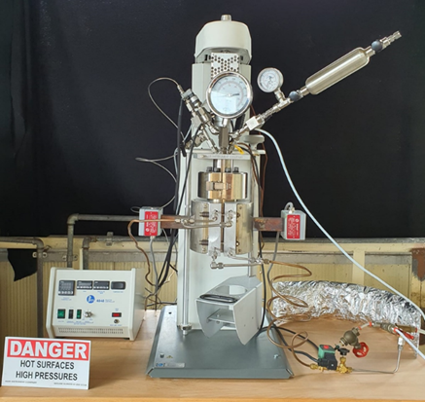 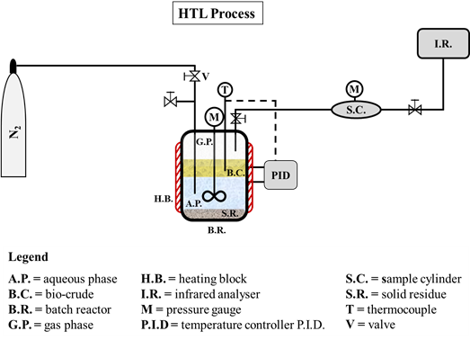

*Figure 1: Batch autoclave reactor of 500 mL; picture (on the left) and layout (on the right) of the lab-scale apparatus.*

For the HTL test, the reactor was loaded with 30 g (dry basis) of a municipal sludge together with 270 mL of distilled water so to obtain a slurry with a 10%wt solid content, to reproduce the typical sewage sludge concentration value obtained downstream of wastewater treatment plants. Then, the reactor was purged four times with nitrogen at 5 bar to remove the oxygen present in the vessel.

The following stages are thereafter performed: a) first pressurization stage with N2 fed by a gas cylinder at 30 bar; b) second pressurization stage at 200 bar by rapid heating of the system to the desired temperature level; c) running the HTL test at fixed time/temperature level (tested temperatures 300 and 350 °C – 20 min of isothermal stage); d) fast cooling of the reactor so to "freeze" chemical reactions, thus avoiding products re-distribution during thermal transients; e) depressurization of the reactor and sampling of the gas obtained from the HTL process. At the end of the test, liquid–solid phases separation was performed by coupling filtration, Soxhlet and liquid–liquid extraction with dichloromethane (DCM) and distillation.

**2.3 Products separation procedures**

Figure 2 depicts the scheme adopted for the separation and extraction of the hydrothermal liquefaction products. After the HTL test, the gas phase was vented to the atmosphere via a needle valve to restore ambient pressure and allowing reactor discharge. To minimise the use of solvents for environmental purposes, most of the liquid and solid phases were recovered from the vessel with a spatula. Then, 28 g of DCM was used to wash the wall of the reactor to maximise the products recovery. Subsequently, the recovered slurry was filtered on a Büchner under vacuum, and 30 g of DCM were used to wash the solid residue. After filtration, the solid phase was subjected to a Soxhlet extraction with DCM to recover the bio-oil from the solid pores and then dried at 105 °C in the oven for 24 h, while the liquid phase (a mixture of water and DCM) was separated into bio-crude and aqueous phase in a separating funnel. In fact, DCM has a low polarity and solubility in water, so allowing possible to solubilise organic compounds and obtain the extraction of bio-crude. Finally, the bio-oil fractions (also containing the liquid phase from Soxhlet extraction of the solid residue) are obtained by distillation vs. DCM under vacuum at 40 ºC, and subsequently weighed to estimate its yield. The solid and bio-crude yields *Y* were calculated according to equations (1) and (2), respectively:

$Y_{Solid}= \frac{m_{solid, db}}{m_{biomass, db}}∙100$ Eq(1)

$Y_{Bio-crude}= \frac{m_{bio-crude}}{m_{biomass, dafb}}∙100$ Eq(2)

where *msolid,db*, *mbio-crude* and *mbiomass,dafb* represent the mass of solid residue, bio-crude and starting biomass, respectively. The subscripts “*db*” and “*dafb*” refers to dry and dry ash-free basis, respectively.

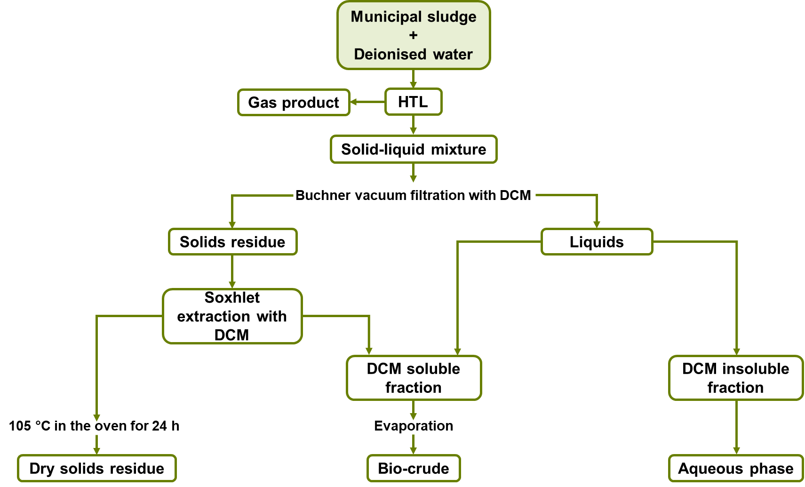

*Figure 2: Experimental protocol for the separation of HTL products.*

* 1. Results

In the following paragraphs the results of the setup of the HTL apparatus, together with the preliminary results of the HTL tests performed on the sludge, are reported.

3.1 Setup of HTL apparatus and heating/cooling rate for HTL system

The heating/cooling rate upon HTL tests must be as high as possible, to limit to the formation of undesirable products. Moreover, this rate affects the time-dependent evolution of phases produced along the isothermal stage of HTL.

Figure 3 reports the experimental time-dependent thermal profiles obtained by heating the reactor from room temperature to the operating temperature of 340 °C, the latter chosen as a reference from a preliminary literature analysis (Di Lauro et al. 2020). The blue curve “base system” represents the temperature in the reactor when water is heated by only using the electric heating block of the system (co-axial with the reactor), while the orange curve “upgraded system” is obtained by heating the reactor also with the support of a 1000 W heating plate located on the bottom of the vessel and by thermally insulating the head of the reactor with a layer of rock wool. Two regions of interest are highlighted: the red one for temperature values between 200–280 °C, and the green one between 290–340 °C. During HTL test, the permanence of the system in the red region, over a period of 40–120 min, leads to the preferential formation of bio-char, while the temperature range highlighted by the green region leads to the preferential formation of bio-oil for characteristic reaction times of 15–30 min.

Results show that, for the base system, a total heating time of 85 min is required: the system persists for about 25 min in the region of preferential bio-char formation and remains for 30 min in the range of temperatures characteristic of bio-oil formation, before reaching the desired final temperature of 340 °C. Overall, the mean heating rate is about 4 °C/min, value typical for HTL process carried out in reactors of similar size (see for example Brand et al. (2014) and Table 1 reported therein).

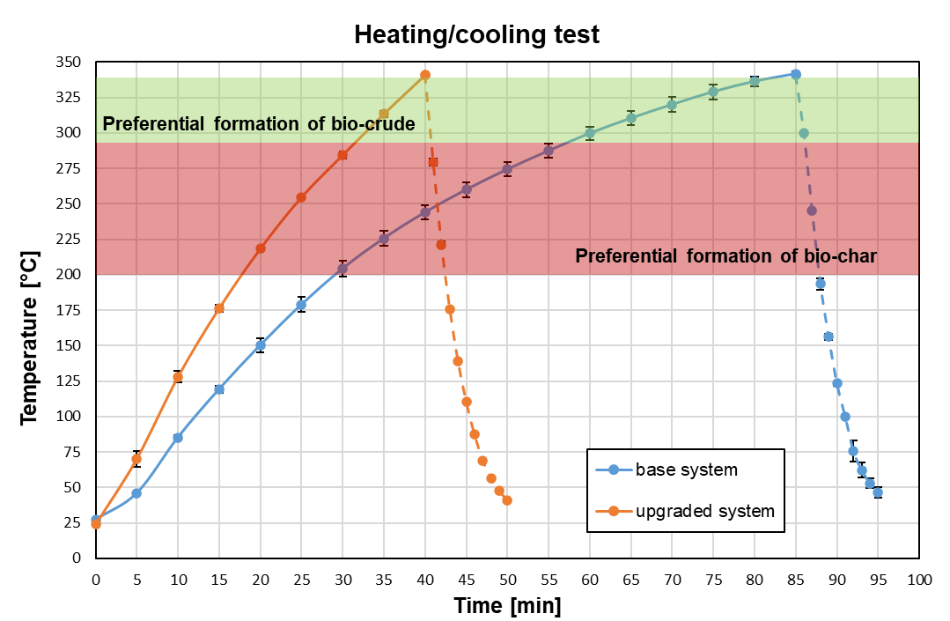

*Figure 3:* *Performance of heating and cooling of HTL reactor, expressed as temperature-time plots. Tests carried out in triplicates.*

From literature data, during HTL test, the permanence of the system in the red region over a period of 40–120 min leads to the preferential formation of bio-char, while the temperature range highlighted by the green region leads to the preferential formation of bio-oil for characteristic reaction times of 15–30 min. For the upgraded system, a significant amelioration of the heating rate is attained, about 8 °C/min, with the total heating time being practically halved with respect to the base system; the permanence in the region of preferential formation of bio-char is limited to 15 min. This result is encouraging for the minimisation of the course of the undesired reactions during the HTL tests in the upgraded configuration of the 500 mL batch reactor. For both systems, the cooling stage is very fast and in the order of 5 min with a mean cooling rate of about 30 °C/min.

3.2 Municipal sludge HTL test and yields of products

After the optimisation of the HTL reactor, the municipal sludge was used for preliminary hydrothermal liquefaction tests performed at 300 and 350 °C and 200 bar for 20 min, to verify the bio-oil and solid residue yield under the tested condition (Di Lauro et al. 2021). The pressure vs temperature curve during the thermal transient and the isothermal step, for the upgraded system during the municipal sludge HTL test, is reported in Figure 4 together with transient data obtained under unreactive conditions similar to those shown in Figure 3 (orange curve). It is worth to note that the evolution of pressure as a function of temperature during the HTL test can be almost overlapped to that under unreactive conditions up to the temperature of about 320 ºC. The subsequent increase in temperature, during the sludge HTL test, causes a sudden rise of pressure compared to that observed under unreactive conditions caused only by the change of temperature. It is very likely that this increase is associated with the onset of biomass decomposition reactions leading to the formation of gaseous products. This evidence confirms, as it is also reported in literature on HTL, that at lower temperatures the biomass fragments producing intermediate compounds prone to the formation of bio-oil, whereas at higher temperature secondary decomposition reactions and the Boudouard reaction starts to take place promoting the formation of gaseous species (Akhtar and Amin, 2011).

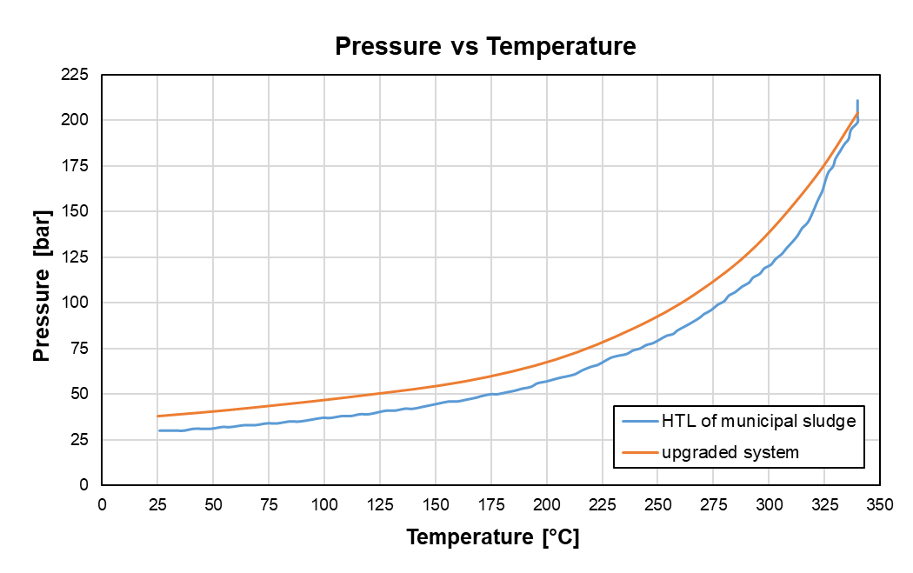

*Figure 4: Evolution of pressure as a function of temperature, for the upgraded system during municipal sludge HTL test.*

Results of the HTL runs showed that *YBio-crude* is 38.3% at 350 °C, a value approximately 10% greater than the figure obtained at the lower tested temperature (equal to 27.9%), thus testifying that the rise of temperature is beneficial in promoting the reaction pathways leading to the desired decomposition of organic molecules to produce the target bio-crude. These values for bio-crude fall within the range of values (at 300 °C 22–28%; at 350 °C 22–53% for 20–30min reaction time) reported in literature for HTL from sludge (Basar et al., 2021). Conversely, the increase of the HTL process temperature produces a reduction of *YSolid* that is 33.6% and 25.9% at 300 and 350 °C, respectively. In this context, it is highlighted that the inorganic fraction of the parent biomass, the char deriving from the HTL process and the unconverted organic matrix of the sludge all contribute to $Y_{Solid}$. These values are relatively nearby the ash yield on dry basis (24.1%), which can be calculated by proximate analysis. This indicates that probably the mean heating and cooling rates obtained with the upgraded system are sufficiently fast to limit the course of the undesired reactions leading to biochar formation and the fraction of the unconverted biomass. Further investigations will be carried out under different conditions of reaction time, heating rate and temperature to verify the effect of these variables on *YBio-crude*.

* 1. Conclusions

In this work, a 500 mL lab-scale batch plant devoted to HTL tests was optimised to minimise thermal transients that could lead to the formation of undesirable products along the hydrothermal conversion process. A significant reduction of the thermal transient was attained with the use of a 1000 W heating plate placed at the bottom of the vessel, and by thermally insulating the top of the reactor with a layer of rock wool, with the total heating time being practically halved with respect to the base system (mean heating rate of 8 °C/min). For both systems, the cooling stage is very fast and in the order of 5 min (mean cooling rate of 30 °C/min). After the setup and optimisation of the experimental apparatus, preliminary tests of HTL were carried out on a municipal sludge, and a bio-crude yield of 38.3% was obtained at 350 °C in agreement with data present in literature. Future studies will focus on a more detailed study of the effect of operating conditions on bio-oil yield and quality.

Acknowledgments

This work has been carried out as part of the Italian national research project ‘Biofeedstock’ PONARS01\_00985, in the framework of the MIUR PNR 2015-2020 programme.

References

<https://www.iea.org/data-and-statistics/data-browser/?country=WORLD&fuel=Energy%20supply&indicator=TESbySource>, accessed on February 2022.

Akhtar J., Amin N.A.S, 2011, A review on process conditions for optimum bio-oil yield in hydrothermal liquefaction of biomass, Renewable and Sustainable Energy Reviews, 15, 1615–1624.

Bach Q.V., Tran K.Q., Lystad K.Q., 2016, Fast hydrothermal liquefaction of macro-alga: characterization of products, Chemical Engineering Transactions, 50, 97–102.

Basar I.A., Liu H., Carrere H., Trably E., Eskicioglu C., 2021, A review on key design and operational parameters to optimize and develop hydrothermal liquefaction of biomass for biorefinery applications, Green Chemistry, 23, 1404–1446.

Brand S., Hardi F., Kim J., Suh D.J., 2014, Effect of heating rate on biomass liquefaction: differences between subcritical water and supercritical ethanol, Energy, 68, 420–427.

Cammarota A., Cammarota F., Chirone R., Ruoppolo G., Solimene R., Urciuolo M., 2019, Fluidized bed combustion of pelletized sewage sludge in a pilot scale reactor, Combustion Science and Technology, 191, 1661–1676.

Castello D., Pedersen T.H., Rosendahl L.A., 2018, Continuous hydrothermal liquefaction of biomass: A critical review, Energies, 11, 3165.

Di Lauro F., Balsamo M., Solimene R., Montagnaro F., Salatino P., 2020, Hydrothermal liquefaction for the production of energetic vectors from residual materials: literature analysis and characterisation of a tannery sludge, Proceedings of the 8th International Symposium on Energy from Biomass and Waste, Virtual Conference.

Di Lauro F., Balsamo M., Solimene R., Migliaccio R., Caracciolo D., Salatino P., Montagnaro F., 2021, Outline of a process for the hydrothermal liquefaction of a tannery sludge for biofuel production, Proceedings of the 10th European Combustion Meeting, 274, Naples, Italy.

Gollakota A.R.K., Kishore N., Gu S., 2018, A review on hydrothermal liquefaction of biomass, Renewable and Sustainable Energy Reviews, 81, 1378–1392

He C., Chen C.L., Giannis A., Yang Y.H., Wang J.Y., 2014, Hydrothermal gasification of sewage sludge and model compounds for renewable hydrogen production: A review, Renewable and Sustainable Energy Reviews, 39, 1127–1142.

Malins K., Kampars V., Brinks J., Neibolte I., Murnieks R., Kampare R., 2015, Bio-oil from thermo-chemical hydro-liquefaction of wet sewage sludge, Bioresource Technology 187, 23–29.

Mujahid R., Riaz A., Insyani R., Kim J., 2020, A centrifugation-first approach for recovering high-yield bio-oil with high calorific values in biomass liquefaction: A case study of sewage sludge, Fuel, 262, 116628.

Qian L., Wang S., Savage P.E., 2017, Hydrothermal liquefaction of sewage sludge under isothermal and fast conditions, Bioresource Technology, 232, 27–34.

Rahman T., Jahromi H., Roy P., Adhikari S., Hassani E., Oh T.S., 2021, Hydrothermal liquefaction of municipal sewage sludge: Effect of red mud catalyst in ethylene and inert ambiences, Energy Conversion and Management, 245, 114615.

Rizzo A.M., Dell’Orco S., Miliotti E., Chiaramonti D., 2020, Design, commissioning and start-up of a new hydrothermal liquefaction continuous pilot unit, Chemical Engineering Transactions, 80, 367–372.

Theegala C.S. and Midgett J.S., 2012, Hydrothermal liquefaction of separated dairy manure for production of bio-oils with simultaneous waste treatment, Bioresource Technology, 107, 456–463.

Wang L., Chang Y., Li A., 2019, Hydrothermal carbonization for energy-efficient processing of sewage sludge: A review, Renewable and Sustainable Energy Reviews, 108, 423–440.